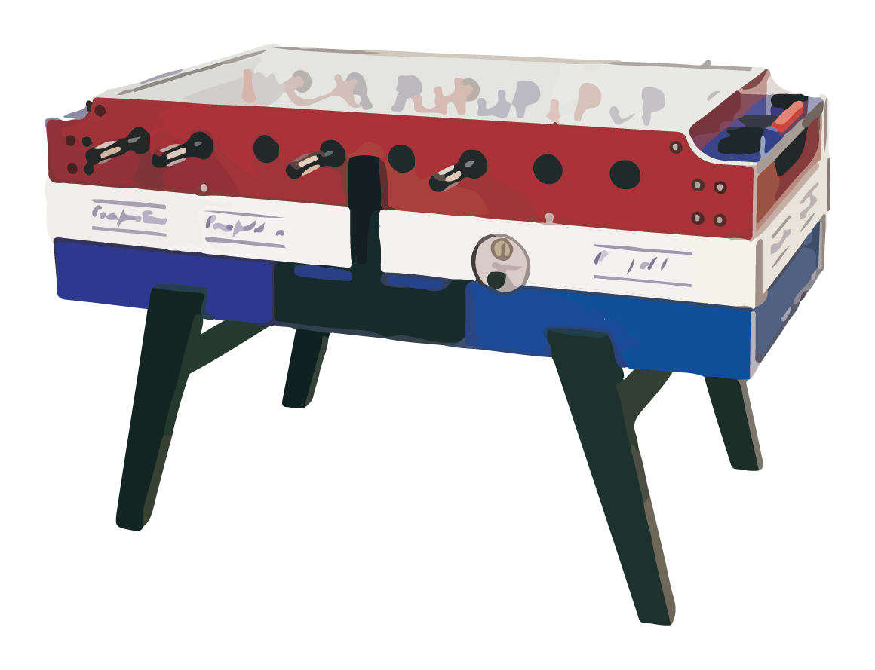

Foosball Handbook
Volume 1
Author: Luke Jones

Standard Moves

Move: The Trombone
Description: A staple of any player’s repertoire, the trombone is becoming an increasing difficult move to pull off. A trombone occurs when the ball is hit down the middle of the field into the goal at a somewhat embarrassingly slow speed.

Move: The Punisher Other Names: The Humiliator
Description: A strong statement, the punisher is performed when a striker blocks the keeper’s shot and sends it back into the goal. Variants of this move include the midfield punisher, and the Humiliation Punish, where a punish is performed by shooting at the exact time the keeper shoots.
A brutal move.

Move: The Bamboozle Other Names: The Ol’ Bambozzler
Description: An awesome move, the bamboozle has been known to baffle even the greatest of defences throughout it’s time. A bamboozle is performed by hitting the ball so that it bounces off the wall and into the goal at extreme and unpredictable angles. The bamboozle can be used by players of all skill levels, it is a move that is easy to pick up, but very difficult to master.
A true classic.

Move: The Bobbler
Description: The bane of many defender’s lives, the Bobbler has a habit of rearing its ugly head in the most even encounters, and is usually the difference between the men and the boys. The Bobbler occurs when a shot of considerable power is hit off the back wall, or indeed saved by the keeper, and proceeds to jump itself into the goal.
A true heartbreaker.

Move: The Pick Up
Description: More a test of reactions than a move, the Pick Up is performed by catching the ball as it makes its way through the field and hitting it with perfect timing to score a great goal. Simple, yet very effective.

Move: The Pinball Wizardry
Description: First coined by Jason Gemson, the Pinball Wizardry is usually seen in moments of true chaos, when the ball is flying about and none of the four players have a clue what is happening, and are lashing out at anything that moves. The ball will take multiple deflections at high speed on it’s way to the net. Near unstoppable.

Move: The Squirter
Description: The Squirter is an ancient technique that many had thought extinct, until David Gebbett made his way to the table. Reviving this long forgotten move, David developed a game style built almost solely around the use of this move. A Squirter is executed by catching the ball on the edge of a player’s feet, with the player then pressing down on the edge of the ball, thus creating a classic squirt. Although many debate the effectiveness of the Squirter, it remains a fan favourite due to its rareness and unpredictability.

Move: The Stub Other Names: The Stubbaage
Description: The Stubbaage is an underutilised move which can throw off many organised defences. To successfully pull off the stub, a player must hit the ball when it is further back than normal in relation to the player’s feet, thus creating a stub on impact effect which causes the ball to travel at a slower than expected speed. A word of warning though, a Stubbaage is a risky move, and if timed poorly, can lead to the very unwanted wrist-breaker scenario, which is sadly one of the many dangerous possibilities that can occur on the foosball field.

Move: The D-I-Y (Can evolve into the Self-Destruct)
Description: A distant cousin of the Bobbler, the D-I-Y is a fascinating move, and much like the Bobbler occurs when the ball bounces off the back or side walls and off the keeper into the net. The difference of this move is that is has a strong helping hand over the line from the keeper himself and is one of the more humiliating times to be a player. If performed more than twice in one game, the D-I-Y can evolve into its bigger, older brother, the Self-Destruct. Many strong relationships have been broken by a keeper’s performing the Self-Destruct at the end of a big game.

Move: The Ice Breaker
Description: A move which makes you thankful for the glass top, the Ice Breaker is when a player gets under the ball and attempts to launch it into orbit, only for the Perspex to get in the way.

Move: The Noah’s Ark Other Names: The Ark
Description: The Noah’s Ark is a true test of a player’s belief, and is an indicator of whether or not they have been praying to the Foosball Gods. The Ark is a phenomenon that occurs when the ball rolls down the line between two sets of opposing players, and is out of reach for both. It then calls to the Gods to make a choice, before slowly changing its path to give itself to the more deserving player. They say the joy of winning the Ark is a feeling that lasts with you for a long time.

Move: The Rimmer
Description: A moment which leaves fans and players alike on the edge of their seats, the Rimmer can be the best or the worst thing to happen to you in a match. This happens when a ball rolls down the line and into the corner, only to roll behind a keeper and across the goal line. Much like the Noah’s Ark, the Rimmer makes a choice and favours one team, either rolling over the line or back to safety. To this day, no one truly knows how the Rimmer decides who to side with.

Move: The Whitewash Other names: Whitey
Description: This is the ultimate aim for any team, and the ultimate defeat you can sustain in a foosball game. A whitewash is a 10 – 0 thrashing. It can leave the winning team riding a high all week, whilst the losing team hang their heads in shame until they may redeem themselves at the table. Being on the wrong end of a whitewash on a Friday afternoon is the worst scenario possible for any player, making it almost impossible to enjoy any aspect of your weekend. You may find yourself being rude to loved ones, or even switching off emotionally from the world, the whitewash loss is a cruel experience.

Advanced Moves

Move: The Doubler Other Names: D-Double
Description: The Doubler is a nasty move to defend, and consists of a combination of power and spin that creates a double shot. The Keeper makes the first big save and is happy with himself, yet unbeknownst to him, that was just a diversion and the ball is coming back for a second time. It is rare that a keeper will be of the level of awareness required to stop it.

Move: The Two-Pointer
Description: A real fan favourite, the two pointer is a rare beast, and a moment of ultimate personal pride to the lucky player who pulls it off. The Two-Pointer has only one aim, to be hit with so much ferocity that the goal cannot contain it and it bursts back onto the field of play, however it is nothing without the follow up goal. This creates a fantastic moment for the fans, as both teams then battle it out to either score the second point, or strike back and cancel out the first goal.
This is why we play Foosball.

Move: The Chipolata
Description: A deceptively hard move to pull off, and many doubt whether anyone has ever truly pulled one off on purpose, the Chipolata is a force to be reckoned with. It involves chipping the ball over the defenders and keeper, making a mockery of even the toughest defences. A modern move, it is none the less something all defences should be wary of. Can also be used in the scoop variant, which is arguably even more difficult to defend against.

Move: The Fireball Other Names: The Bulldozer
Description: A move made popular by Luke S, Andrew and the Bulldozer Tozer, the fireball is a deadly weapon that all great defenders have in their arsenal. When timed correctly it is almost impossible to stop, and has been known to get in a groove where the opposing team’s players may as well be made of air. The defender traps the ball at one side, drags the ball in towards the goal, and toe-punts it all the way down the field into the back of the net. I have a personal vendetta against this move, having been on the receiving end of the Bulldozer’s fireballs too many times, the Fireball is a move which can haunt you in your sleep. May require therapy to recover from.

Move: The Impossi-Angle
Description: A move which leaves players staggered, the Impossi-angle is a shot that finds its way into the goal against all odds and laws of physics. A defender may have all angles covered, with an impenetrable brick wall set up in front of goal, only for the ball to slice right through like a hot knife through butter. Some of the more brutal Impossi-angles have be known to render a player speechless for the remainder of the game. This move does have a counter though, which is the Impossi-save. This is a save which has no business taking place, a save in which the keeper seemingly brings the ball back from beyond the grave, or in this case the goal line, to stop the other teams celebrations in their tracks. Usually involves multiple collisions with the posts.

Move: The Put-Back
Description: A highly advanced technique, the Put-Back is the ultimate in showboating. It is a true sign of a player’s skill when they trap the ball with their front players, only to role it back to the surprise of the defence, and in one smooth motion proceed to shoot with the players from behind and score. A mark of true brilliance, every good player must make the pilgrimage to the Foosball holy land if they are to master this shot. Many believe that Luke S indeed made this journey when he went to China earlier in the year, as he did not come back the same player that he was when he left.
Move: The Alley-oop
Description: Teamwork at its finest, the Alley-oop is a move for when the times are good. A long range pass from the defending player bounces back off the wall at the end, only to be combined with a beautiful pick up from the attacking player who smashes it into the goal with one touch.
(For this move to be attempted, team chemistry and morale must both be at 90% or greater).

Move: The Russian Roulette
Description: A move brought back kicking and screaming into the modern game by the Bulldozer Tozer, the Russian Roulette is a move that lives for the Put in. As the ball is entered into the game, the offending player brave enough to attempt this move will role his arm down the pole, causing a vortex in which the ball can fire from any angle. Has been known to be the cause of some exquisite own goals.
Move: Archaeology
Description: Another move created by Jason Gemson, the Archaeology is appropriately named as the player manages to grab the ball and shoot when it seemed the ball was out of his reach, hence the Archaeological Dig. Hard to see coming.
Move: The 301
Description: A 301 is a redirect with permanent consequences, namely a goal. Along with its Pinball wizardry cousin, a well-timed 301 is impossible to defend against. A favourite of the more scrappy players.
Trademark Moves

Move: The ‘Ryan’
Description: A simple but devastatingly effective attacking move, the Ryan is a move which involves stopping the ball with the left striker and rolling it across the line of attackers. However instead of hitting the ball with the middle striker, the ball is left to roll to the right striker who smashes the ball back across the face of the goal and into the left corner.
Move: The ‘Stephenson Put-In’ Other Names: Turbo Mode
Description: A trademark of the Luke S game, the ‘Stephenson Put-in’ is a deadly move that involves rolling the ball in with extreme accuracy down the line and off the wall. Unless the defending player utilises spring compression with near-perfect timing, the ball will sneak around the back of their midfield and into the strikers greedy clutches. This move has a habit of being used multiple times (turbo mode) and can turn the tide of any battle in a matter or moments. Often leaves defences saying “What the hell happened?!”
Move: The Gemson Bing-er
Description: Basically a slap shot in nature, the Gemson Bing-er is a stronger cousin of the Trombone, and can be recognised with the trademark ‘slap’ sound as the keeper clips the goal before pile driving the ball down the field. Requires a gym membership to stop.
Move: The Shot-Save
Description: A big and brash move made famous by Liam Hicks, the Shot- Save is a move used by the keepers of old, when men were made of sterner stuff. A Shot-Save is what it sounds like, a save made not with a block, but with a return shot made at the right time. Very risky, very cool. What makes this even more remarkable is that it is the only save Liam performs.
Move: The Whirlwind Other Names: The Solar Winds
Description: Less of a move and more of a lifestyle, the Whirlwind is a technique used by our new apprentice to stop incoming shots and is unbelievably effective at throwing off even seasoned players in attack. This style consists of high energy movements of the keeper and defence to cover more angles at once than humanly possible, with a high rate of success. This is also usually combined with the side-swipe style of clearance. The downside to this style is that it can occur a high-rate of own goals, as well as being a hard level of energy to keep up for the less fit players.
Move: The Baffler
Description: A move favoured by the more skilful players such as Andrew W, the Baffler involves making a lot of movement around a stationary ball with your player before striking. Although it may seem pointless at first, the excess movement scrambles the player’s brain momentarily allowing for an opening to occur in the defence.

Illegal Moves

Move: The Spinner
Description: The Spinner is a highly illegal move that occurs when a shot is taken and the player removes all contact with the poles, usually causing a spin shot. Friendships have been destroyed by the use of a spinner to score important goals. Use with caution.

Move: The First Touch
Description: A relatively newly added law to the world of Foosball, the first touch of any midfield player when a ball is put in cannot be a legitimate goal. Although harsh to be on the receiving end, this rule has helped to bring some order to an otherwise chaotic game.

Tactical Moves
Move: The Hand Dryer
Description: Usually occurs during tournament games or highly competitive games, the hand dryer is a moment of calm within the storm when a player can dry his hands from the excess sweat caused by a high stakes game. Slippery poles are a foosball player’s worst enemy.

